# CS 255 System Design Document Template

Brandon T Porter

Brandon.porter2@Snhu.edu

## UML Diagrams

### UML Activity Diagrams

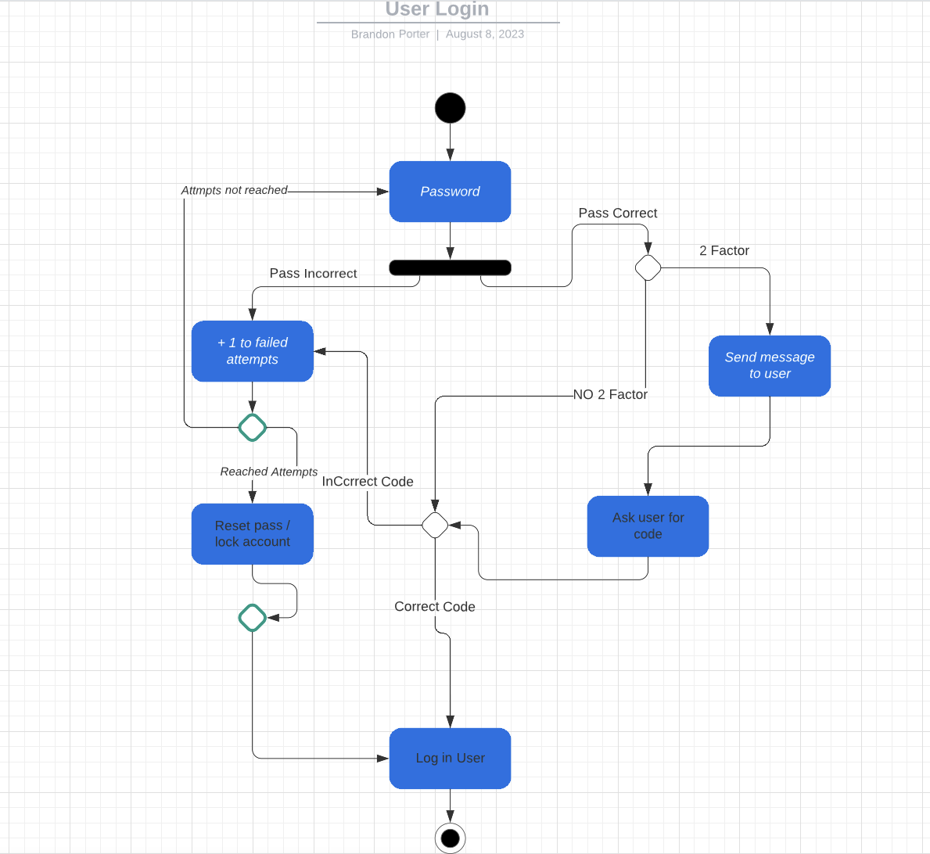

## Technical Requirements

**Hardware Requirements:**

* One or preferably two physical servers for redundancy and backup purposes.
* Necessary input devices such as keyboards and mice for interaction monitoring.
* Reliable internet provider for connectivity.

**Software Requirements:**

* An operating system compatible with the software.
* Software for the DriverPass application.
* Robust security software to safeguard against potential hackers and threats.

**Client Software Requirements:**

* Web browser application (e.g., Firefox, Chrome) for accessing the service.
* Compatible operating system (Mac, Linux, Windows) for seamless usage.
* Strong security systems in place to ward off hacking attempts.

**Development Tools:**

* Computers equipped with programming software (e.g., Visual Studio, Eclipse, emacs) for software development.
* Internet connectivity to facilitate server uploads.
* Network administration tools for actively monitoring and identifying suspicious traffic.

**Infrastructure Needs:**

* Reliable server infrastructure to host the service.
* Partnership with a reputable cloud provider for scalability and flexibility.
* High-quality internet service for uninterrupted operations.
* Availability of vehicles for both students and instructors.
* Compliance with state-mandated insurance requirements.
* Established contract with a credit card processing company for financial transactions.